conjugate gradient

Reading Matrix and Vector Input from File

Purpose: This function reads a square matrix A of size n x n and a vector b of size n from a specified file. It ensures the file is properly formatted and handles errors during input parsing.
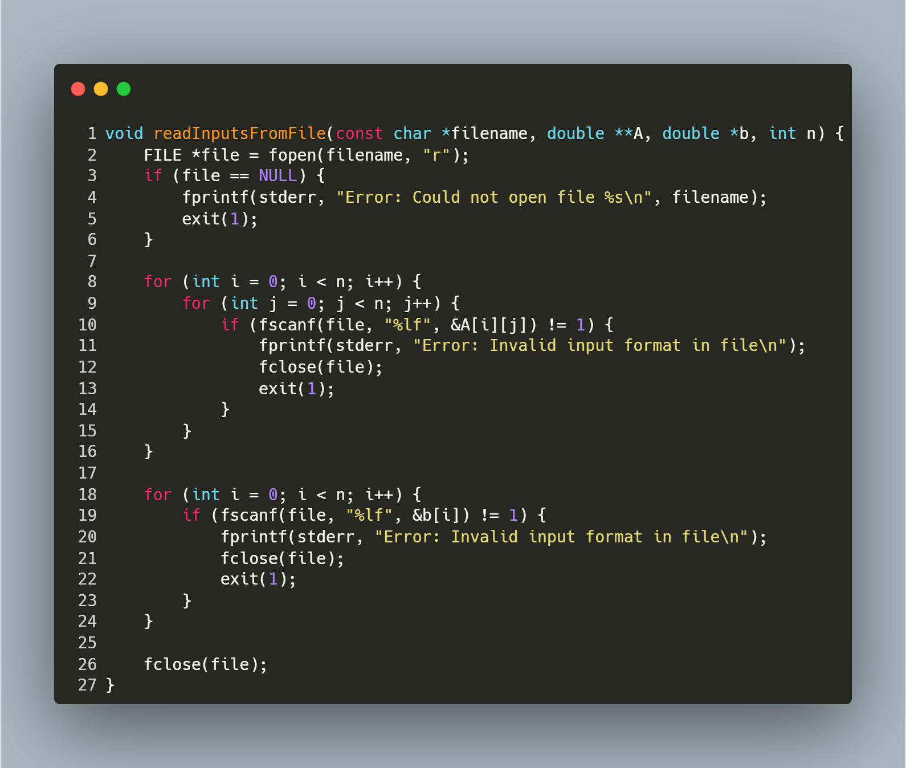
Step-by-Step Explanation
1. Open File
- FILE *file = fopen(filename, "r"); opens the file in read mode.
- If the file cannot be opened (e.g., it does not exist), the function prints an error message and exits with status 1.
2. Read Matrix A
- The nested loops iterate over each row (i) and column (j) of the matrix:
  - fscanf(file, "%lf", &A[i][j]) reads a floating-point number into A[i][j].
  - If the read operation fails (e.g., non-numeric data), the function prints an error, closes the file, and exits.
3. Read Vector b
- The loop iterates over each element of the vector:
  - fscanf(file, "%lf", &b[i]) reads a floating-point number into b[i].
  - If the read operation fails, the function prints an error, closes the file, and exits.
4. Close File
- fclose(file); closes the file after all data is read to release system resources.

function: Matrix-Vector Multiplication

Purpose: This function multiplies a square matrix A of size n x n with a vector b of size n and returns the resulting vector. It computes the dot product of each row of A with b.
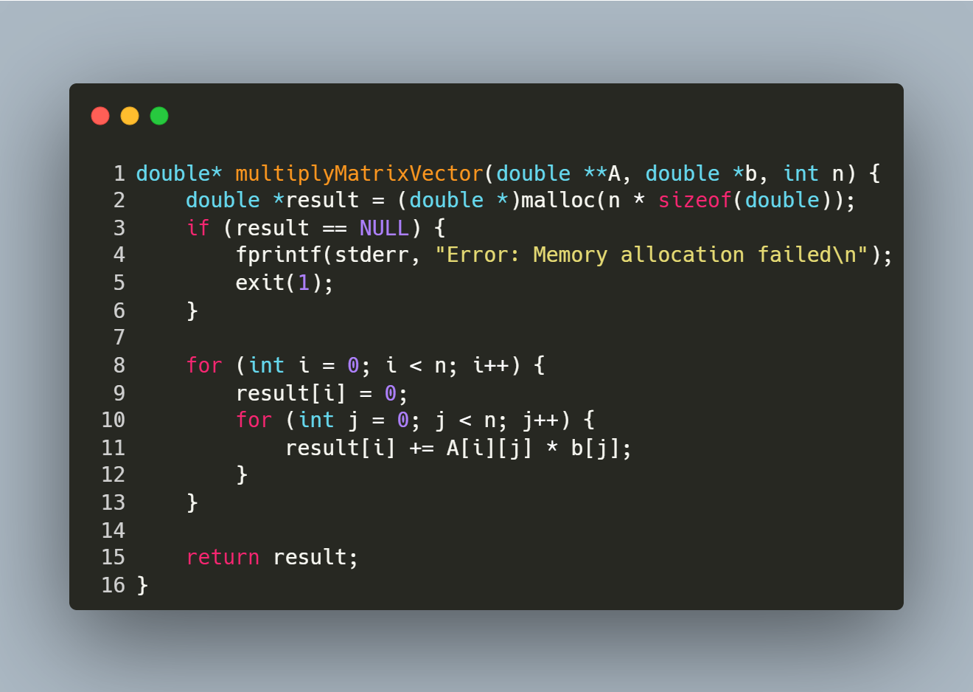
Step-by-Step Explanation
- Memory Allocation:
  - Allocates memory for the result vector result of size n.
  - Exits with an error if memory allocation fails.
- Row Iteration:
  - The outer loop iterates over each row i of the matrix A.
- Dot Product Calculation:
  - Initializes result[i] to 0.
  - The inner loop iterates over each column j of the matrix.
  - Computes the dot product of the i-th row of A and the vector b.
- Return Result:
  - Returns the computed vector result.

function: Vector Subtraction

Purpose: This function computes the element-wise subtraction of two vectors v1 and v2 of size n and returns the result as a new vector
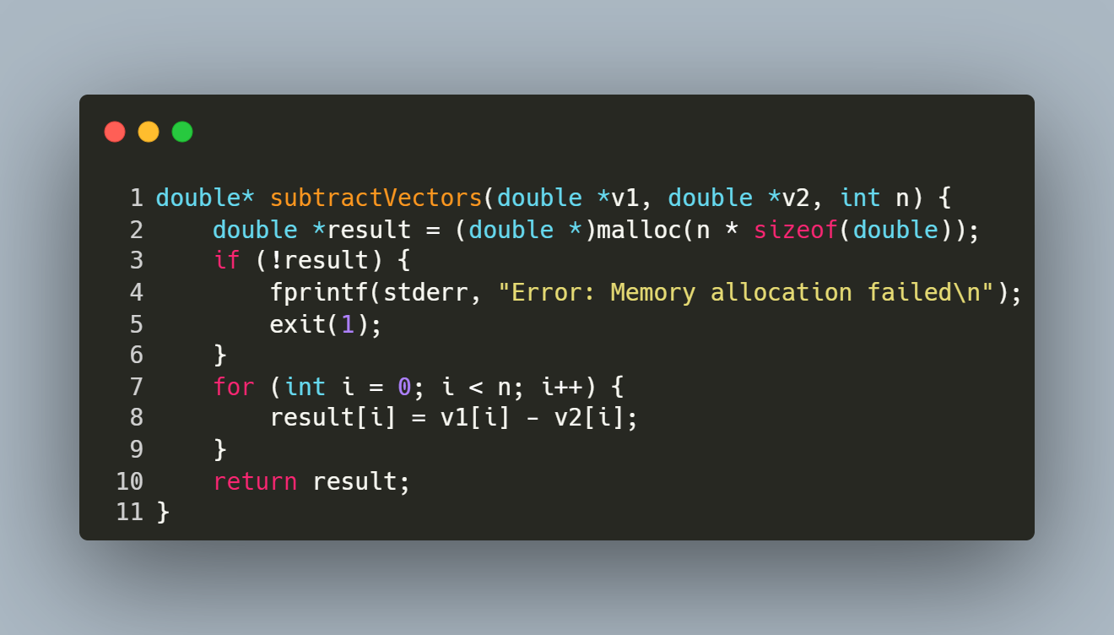
Step-by-Step Explanation
- Memory Allocation:
  - Allocates memory for the result vector result of size n.
  - Exits with an error if memory allocation fails.
- Element-wise Subtraction:
  - Iterates over each index i from 0 to n-1.
  - Computes result[i] = v1[i] - v2[i] for each element.
- Return Result:
  - Returns the vector result containing the difference of v1 and v2.

function: Dot Product of Two Vectors

Purpose: This function computes the dot product of two vectors v1 and v2 of size n
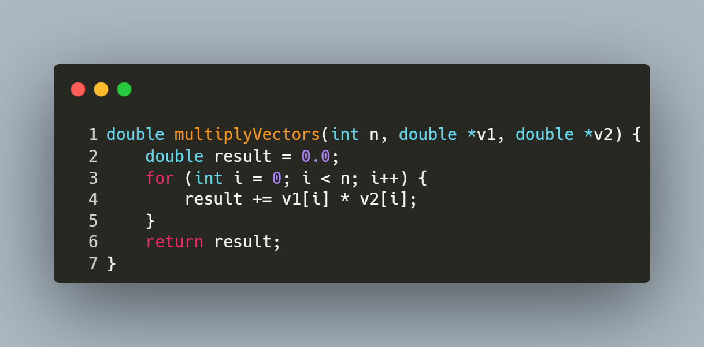
Step-by-Step Explanation
- Initialization:
  - result is initialized to 0.0 to accumulate the sum of products.
- Element-wise Multiplication and Summation:
  - Iterates over each index i from 0 to n-1.
  - Computes the product of corresponding elements v1[i] * v2[i] and adds it to result.
- Return Result:
  - Returns the scalar value result, which is the dot product of the two vectors.

FUNCTION: Conjugate Gradient Method

Purpose: This function solves the linear system Ax = b using the Conjugate Gradient (CG) method, an iterative algorithm optimized for symmetric positive-definite (SPD) matrices. It minimizes the residual error iteratively until convergence.
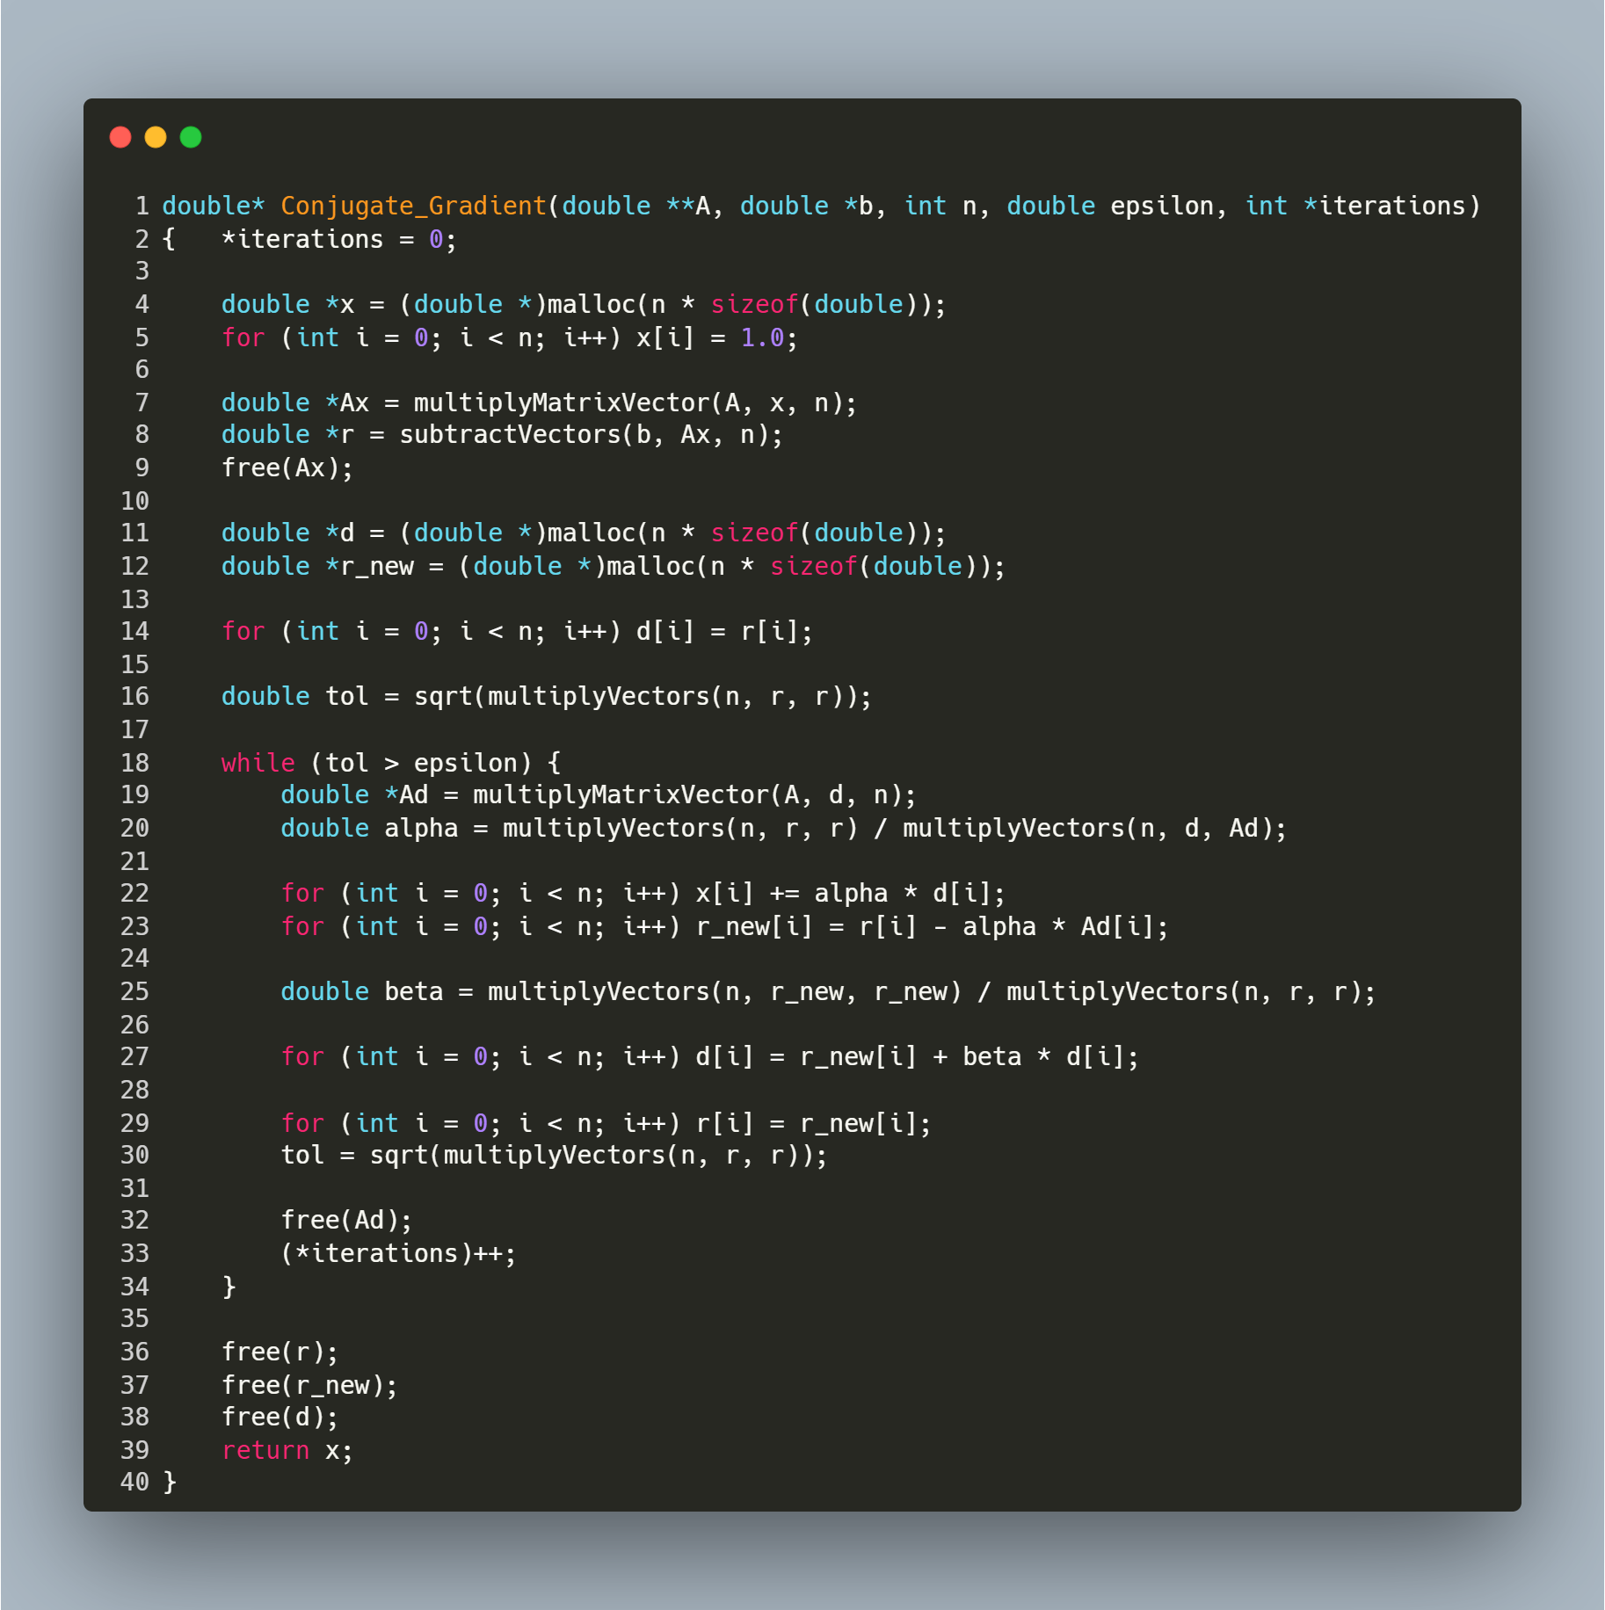
Function Parameters
- A: Symmetric positive-definite matrix (n x n).
- b: Right-hand side vector (size n).
- n: Size of the matrix/vector.
- epsilon: Tolerance threshold for stopping criteria.
- iterations: Output parameter tracking the number of iterations performed.
Returns: Solution vector x.
Step-by-Step Explanation
1. Initialization
- Initial Guess:
double *x = malloc(...);
for (...) x[i] = 1.0; // Initial guess x₀ = [1, 1, ..., 1]
The algorithm starts with an initial guess of x as a vector of ones.
- Residual Calculation:
double *Ax = multiplyMatrixVector(A, x, n);
double *r = subtractVectors(b, Ax, n); // r₀ = b - A x₀
Compute the residual r (error between b and A x).
- Direction Vector:
double *d = malloc(...);
for (...) d[i] = r[i]; // d₀ = r₀
Initialize the search direction d to the residual r.
- Tolerance Check:
double tol = sqrt(multiplyVectors(n, r, r)); // ||r₀||
Calculate the L2 norm of the residual to check convergence.
2. Iterative Loop
The loop continues until the residual norm tol falls below epsilon:
while (tol > epsilon) {
// Step 2.1: Compute α (step size)
double *Ad = multiplyMatrixVector(A, d, n);
double alpha = (rᵀr) / (dᵀ A d);
// Step 2.2: Update x and residual
x += α * d;
r_new = r - α * A d;
// Step 2.3: Compute β (direction adjustment)
double beta = (r_newᵀ r_new) / (rᵀ r);
// Step 2.4: Update direction vector
d = r_new + β * d;
// Step 2.5: Update residual and tolerance
r = r_new;
tol = ||r_new||;
(*iterations)++;
}
Key Steps in Each Iteration:
- Compute Step Size (α):
  - α determines how far to move along the direction d.
  - Formula:
α =$\frac{r^{T}*r}{d^{T}*A*d}$
- Update Solution (x) and Residual (r_new):
  - Adjust x using the step size α and direction d.
  - Update the residual to reflect the new solution: $r_{new}=r-αAd$
- Compute Direction Adjustment (β):
  - β adjusts the search direction to ensure conjugacy with previous directions.
  - Formula:
β=$\frac{r_{new}^{T}*r_{new}}{r^{T}*r}$
- Update Direction Vector (d):
  - Combine the new residual and previous direction:
d=$r_{new}+βd$
3. Termination and Cleanup
- Convergence Check: The loop exits when tol ≤ epsilon.
- Memory Management:
c
free(r); free(r_new); free(d); // Free temporary vectors
- Return Result: The solution vector x is returned.

Main Program for Conjugate Gradient Method
Purpose: This program solves a linear system Ax = b using the Conjugate Gradient (CG) method. It reads the matrix A and vector b from a file, computes the solution x, and prints the results along with performance metrics.
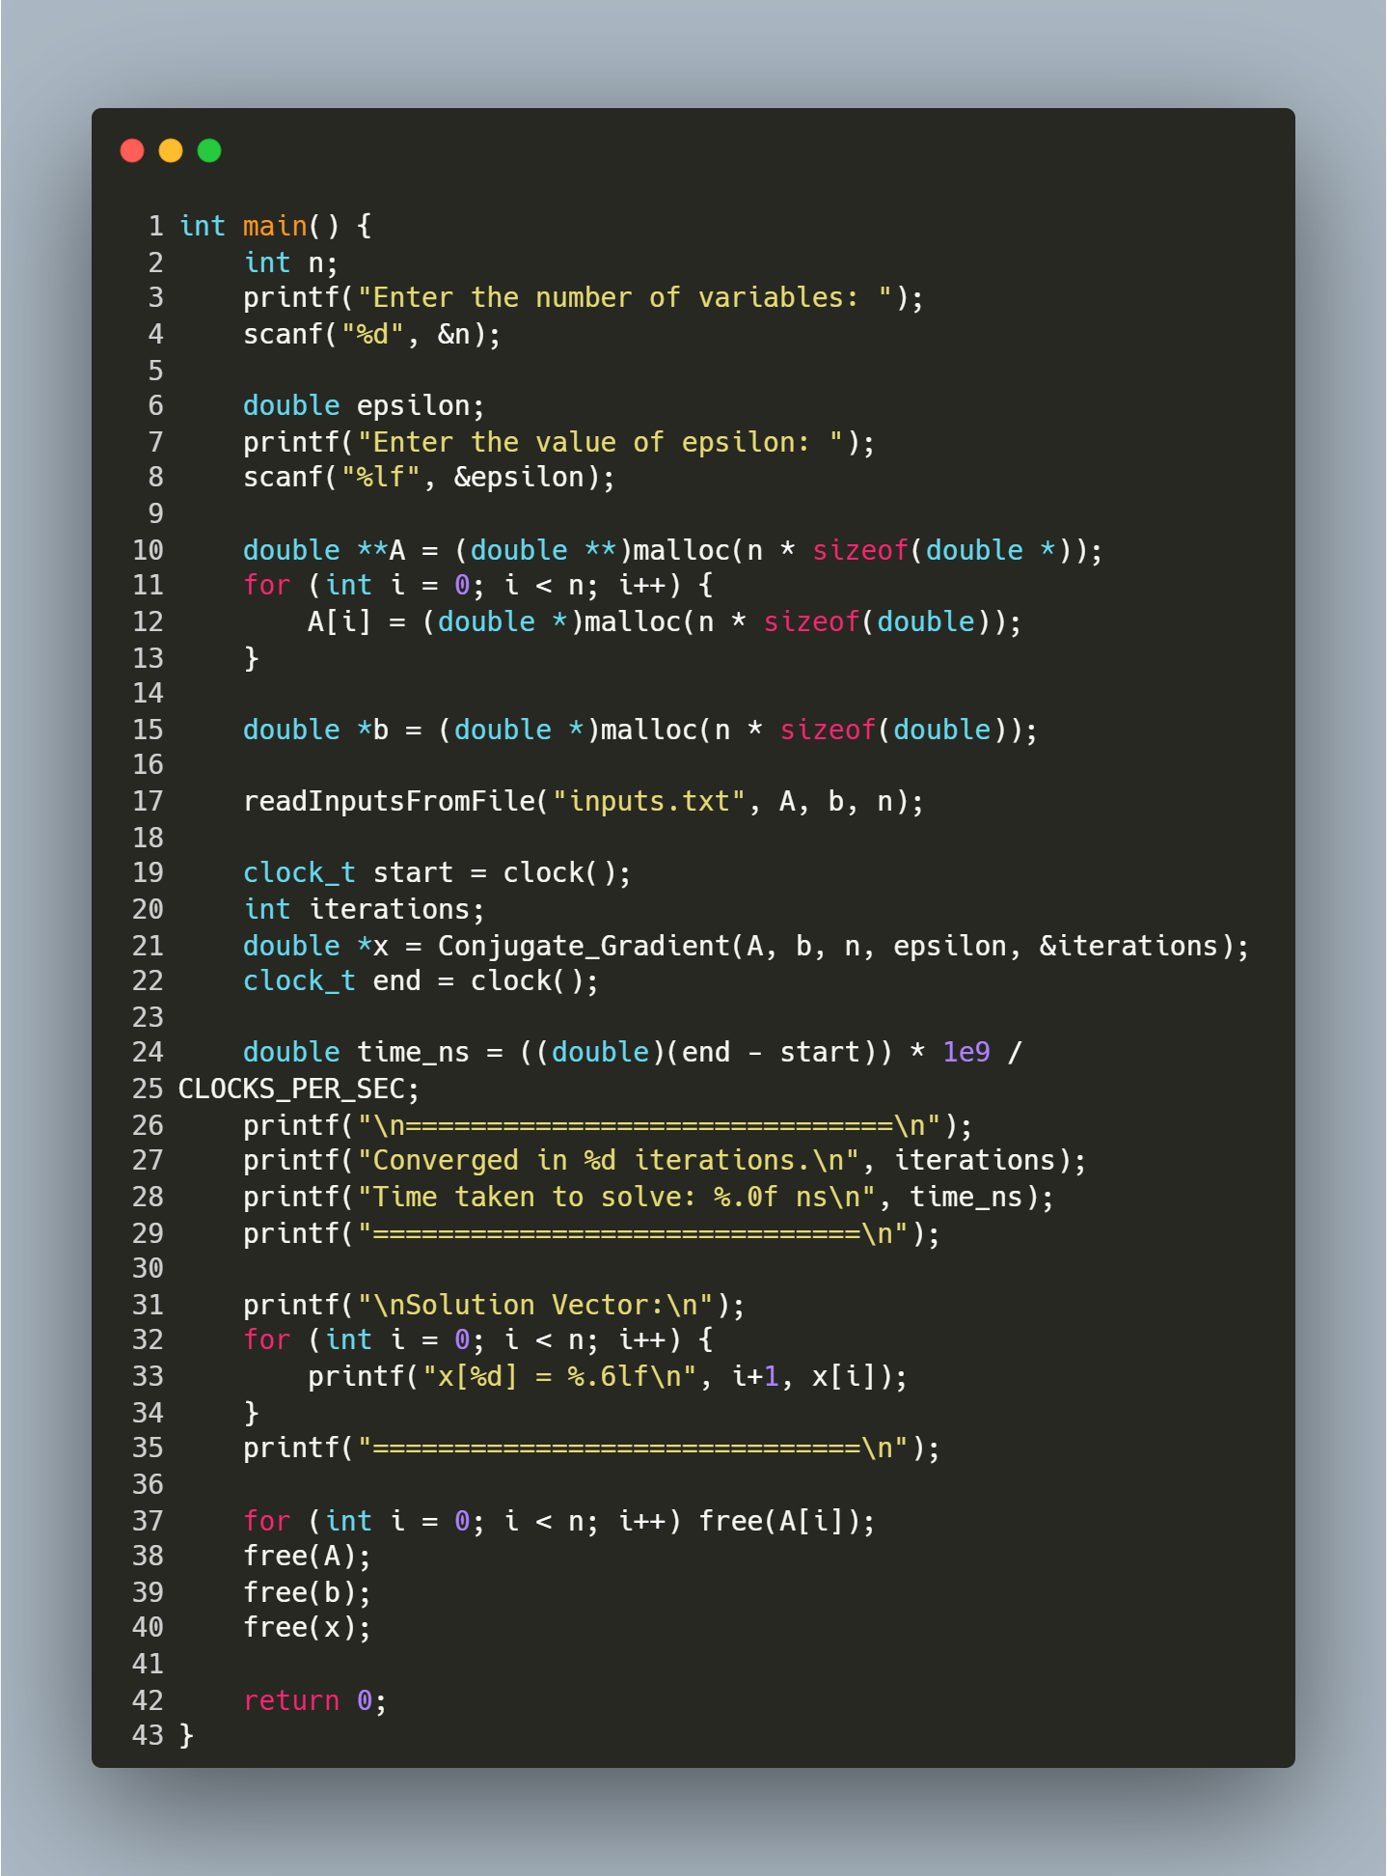
Step-by-Step Explanation
- User Input:
  - Prompts the user for:
    - n: Number of variables (size of the matrix/vector).
    - epsilon: Convergence tolerance (e.g., 1e-6). Smaller values increase precision but may require more iterations.
- Memory Allocation:
  - Allocates memory for:
    - A: n x n matrix (dynamic 2D array).
    - b: Vector of size n.
- Read Input File:
  - Calls readInputsFromFile("inputs.txt", A, b, n) to load A and b from the file.
  - File Format: The file must contain n x n matrix elements followed by n vector elements.
- Solve with Conjugate Gradient:
  - Conjugate_Gradient(A, b, n, epsilon, &iterations) computes the solution vector x.
    - Input: Matrix A, vector b, size n, tolerance epsilon.
    - Output: Solution x and number of iterations to converge.
  - Note: A must be symmetric positive-definite (SPD) for the CG method to work correctly.
- Performance Timing:
  - Uses clock() to measure CPU time taken by the CG method.
  - Converts time to nanoseconds for readability.
- Print Results:
  - Displays the number of iterations and execution time.
  - Prints the solution vector x with 6 decimal places.
- Memory Cleanup:
  - Frees dynamically allocated memory for A, b, and x to prevent leaks.

